

SMART-BIN: AN ESP32-BASED IoT WASTE BIN MONITORING SYSTEM WITH FILL, WEIGHT, AIR-QUALITY AND TAMPER DETECTION
FOR PRIORITY-BASED COLLECTION

Waste Management and Cleanliness
Problem: Overflowing Garbage Bins and Inefficient Waste Collection Routes

Technological University of the Philippines - Manila
Bachelor of Engineering Technology major in Computer Engineering Technology

Embedded Systems: Final Project
BET-CPET 4A-M, Group 2

Submitted By:
Brian Jay Celeste
Genesis Walter D. Reyes II
Jade C. Gunayan
King Perth G. Pepito
Rodel S. Banogbanog

Submitted To:
Prof. Jonel R. Macalisang

November 6, 2026
TABLE OF CONTENTS
TITLE PAGE i
TABLE OF CONTENTS ii
LIST OF FIGURES iii
LIST OF TABLES iv
I. INTRODUCTION 1
1.1 Introduction and Problem 1
1.2 Sustainable Development Goal (SDG) Addressed 2
1.3 Review of Related Literature 3
1.4 Objectives 4
1.5 Conceptual Framework 5
1.6 Target Beneficiaries 8
II. PROTOTYPE DESIGN AND DEVELOPMENT 9
2.1 Prototype Design 9
2.2 Block Diagram 10
2.3 System Flowchart 12
2.4 Schematic Design 18
2.5 Component Materials 21
III. TESTING, RESULTS, AND CONCLUSION 32
3.1 Test Cases 32
3.2 Results and Discussion 32
3.3 Conclusion 32
3.4 Recommendations 32
REFERENCES 33
APPENDICES 35
Appendix A: Gantt Chart 35
Appendix B: Bill of Materials 36
Appendix C: User Interface Screens 37
Appendix D: Source Code 38

LIST OF FIGURES
Figure 1. Sustainable Development Goal 11: Sustainable Cities and Communities 2
Figure 2. System Architecture of Smart-Bin 6
Figure 3. Block Diagram of the Smart-Bin System 10
Figure 4. System Flowchart of the Smart-Bin 12
Figure 5. Operator Flowchart of the Smart-Bin Apps 14
Figure 6. Collector Flowchart of the Smart-Bin Apps 16
Figure 7. Schematic Diagram, Sheet 1: Microcontroller 18
Figure 8. Schematic Diagram, Sheet 2: Actuators and Outputs 19
Figure 9. Schematic Diagram, Sheet 3: Sensors and Inputs 20
Figure 10. ESP32 DevKit V1 (38-Pin, ESP32-WROOM-32D) 21
Figure 11. HC-SR04 Ultrasonic Distance Sensor 22
Figure 12. HC-SR501 PIR Motion Sensor 23
Figure 13. BME680 Environmental Sensor 24
Figure 14. BMI160 Six-Axis Inertial Measurement Unit 25
Figure 15. HX711 Load Cell Amplifier and 5kg Load Cell 26
Figure 16. SG90 Micro Servo Motor 27
Figure 17. 2.4-in. TFT Touchscreen (ILI9341 With XPT2046 Touch Controller) 28
Figure 18. KY-016 RGB LED Module 29
Figure 19. Passive Buzzer Module (MH-FMD) 30
Figure 20. 18650-Battery Shields for Bin A (4-Cell) and Bin B (2-Cell) 31
LIST OF TABLES
Table 1. Bill of Materials of the Smart-Bin Prototype 36

I. INTRODUCTION

1.1 Introduction and Problem
An effective waste management plays a crucial role in creating and sustaining healthy, clean and prosperous communities. With the rising amount of waste that is being generated, it has become a problem for the local government and commercial waste collectors in the Philippines. The Philippines is estimated to be producing a total of 60.76 thousand tons of garbage every day in 2025, according to the Philippine Statistics Authority (PSA, 2026). Despite the significant actions taken by the City of Metro Manila, its garbage is projected to reach 9,498 MT/D in 2020, making it the country's waste capital (World Bank, 2022). This was projected to rise to 10,368 MT per day by 2025 (World Bank, 2022). Hence, a high priority of improving waste management and collection practices in the country. Most garbage collection systems are conducted on a fixed schedule, causing bins to overflow when they are picked up or not to be filled to capacity when collected. Additionally, the smell, pollution levels, temperature, tilting of garbage bins, and unauthorized access should also be monitored as they are important indicators of environmental conditions and the efficiency of garbage management.
The researchers propose the Smart-Bin which is an Internet of Things (IoT) based bin monitoring system based on the ESP32 microcontroller with the aim of improving garbage collection performance. Sensors will be used by Smart-Bin to determine the level of fullness, weight, temperature, humidity, and air quality. It'll also be tracking bins that tilt irregularly, and any unauthorized bin openings, through a web dashboard and mobile application. Smart-Bin includes a touchscreen at the bin for employees to view and acknowledge the collection instructions, as well as to set up PIN codes to select who can access the bin, and to make collection setting changes. The project will include the development of two Smart-Bin prototypes built at the table size that will feature the ESP32 boards, local Wi-Fi, ThingSpeak, web dashboard, Android app, and screen at the bin. Smart-Bin will arrange the list of collection priorities based on fill levels and how long they will take to fill up, with the aim of optimizing garbage collection and fuel consumption rates.

1.2 Sustainable Development Goal (SDG) Addressed
Figure 1
Sustainable Development Goal 11: Sustainable Cities and Communities

The project Smart-Bin is connected to one of the Sustainable Development Goals (SDGs) of the United Nations (Agenda 2030), namely SDG 11: Sustainable Cities and Communities. Smart-Bin is specifically targeting the environmental impact of cities, per capita, with particular attention to air quality and municipal and other waste management (United Nations Department of Economic and Social Affairs [UN DESA], n.d., Target 11.6).
Smart-Bin can contribute to achieve the target of Sustainable Development Goal 11. It is achieved by monitoring and control of waste state with help of sensors installed in smart-bins and collecting information to make timely decision to ensure waste management collection process. As part of the project, a dashboard and application are developed and send a notification to the operator regarding of the bins state (levels, weight, temperatures, humidity, air quality around bins).
It can help in optimizing the collection process since priority can be given to those bins which have more trash and need to be emptied before the trash overflows. Furthermore, it can be used to prevent the impact on the environment, for example, if the air quality is not acceptable. This can optimize the collection process by prioritizing bins and minimizing vehicles and fuel usage.

1.3 Review of Related Literature
[Introduce the review of related literature here.]

Prior Art
[Discuss 15 to 20 existing smart bin products, patents, or prototypes.]

Related Literature and Studies
[Discuss 20 to 30 related literature and studies published in 2023 or later.]

SWOT Analysis
[Insert the SWOT analysis of Smart-Bin here.]

Research Gap
[State the gap in existing systems that Smart-Bin addresses.]

1.4 Objectives

General Objective
To design and develop Smart-Bin, an IoT based Waste Bin Monitoring System which will monitor the fill level, weight and air quality of the waste bin, detect tampering and give real time monitoring and alerts to the concerned entities via Web Based Dashboard, Android App and On-Bin Touchscreen.

Specific Objectives
- Sensor Monitoring and Detection
To develop 2 Smart-Bin units, which include sensors to measure fill level, weight, temperature, humidity and air quality, as well as to detect bin tilting and tampering and open the lid automatically when hand movement is detected.
- Real-Time Monitoring and Alerts
To build a web dashboard and Android app to show real-time sensor data, bin status, retrieve data from ThingSpeak and alert operators and collectors when bins are full, air quality is poor, there is high temperature, tampering or when the bin is not online.
- Bin Control and Collection Prioritization
To implement Collection Prioritization, based on bin fullness and estimated time to fullness, remote bin locking and unlocking, on-bin collection functions (via PIN), sensor simulation and system interface sensor calibration. This will lead to the prioritization of collections and will also help with efficient collection routes and fuel gas efficiency.

1.5 Conceptual Framework
[Introduce the conceptual framework here.]

Input-Process-Output Model
[Insert and explain the IPO diagram here.]

IoT Level
Figure 2
System Architecture of Smart-Bin
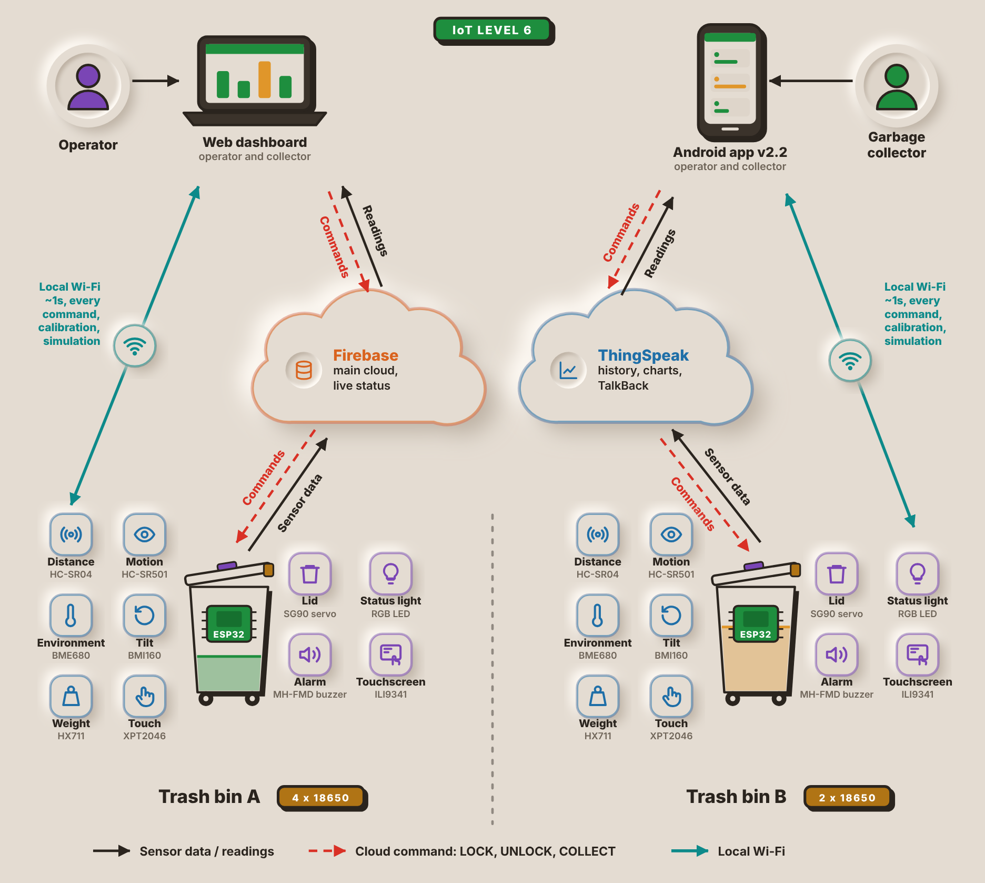
Figure 2 shows how the parts of Smart-Bin connect. From the cloud, the readings reach the two apps at the top: the web dashboard, used mainly by the operator, and the Android app, used mainly by the garbage collector. Both apps can also reach a bin directly over the local Wi-Fi in about 1s for any command, calibration, or simulation.
There are two end nodes at the bottom: Trash bin A and Trash bin B. All are equipped with the same ESP32 and six input sensors (HC-SR04, PIR sensor, BME680, BMI160, load cell, touch panel) and four output actuators (servo, RGB LED, buzzer, TFT). Bin A is powered by 4x 18650 cells, Bin B by 2x.
Each bin sends its sensor data up to two cloud services and receives the LOCK, UNLOCK and COLLECT commands from them. Firebase is the primary cloud and stores the live status, ThingSpeak stores the history and charts and relays commands via TalkBack.
[Explain the IoT level of the system (Bahga & Madisetti) here.]

1.6 Target Beneficiaries
- Waste Collectors and Utility Staff
Smart-Bin will assist waste collectors and utility workers by notifying them which bins are fullest and need to be emptied first. It could also prevent visits to bins that are not full and offer PIN access to the bin during collection.
- Facility Managers and Operators
Facility managers and operators of schools, offices, malls, and barangay halls will benefit from the web dashboard as it allows them to monitor the status of the bins, evaluate the data, set thresholds for sensors, and receive alerts such as messages regarding overflowing bins, poor air quality, high temperature, and possible tampering.
- Barangay and Local Government Unit (LGU) Sanitation Offices
The sanitation offices of barangays and LGUs can utilize Smart-Bin's data readings to aid in garbage collection scheduling and management. Information on the percentage of fullness and time to be full can help them optimize collection routes and reduce fuel consumption by avoiding unnecessary pickups.
- Filipino Citizens
Filipino citizens like students, employees, and residents of schools, offices, or other places would benefit from cleaner surroundings, fewer overflowing trash bins, and more awareness about waste. The hands-free lid would also make it easier and more sanitary to dispose of waste.

II. PROTOTYPE DESIGN AND DEVELOPMENT

2.1 Prototype Design
[Describe and show the physical design of the Smart-Bin prototype here.]

2.2 Block Diagram
The block diagram of one Smart-Bin unit and the network around it is shown in Figure 3. There are two separate ESP32 microcontrollers, one in each of the two bins, and both bins report to the same cloud services and user apps.
Figure 3
Block Diagram of the Smart-Bin System
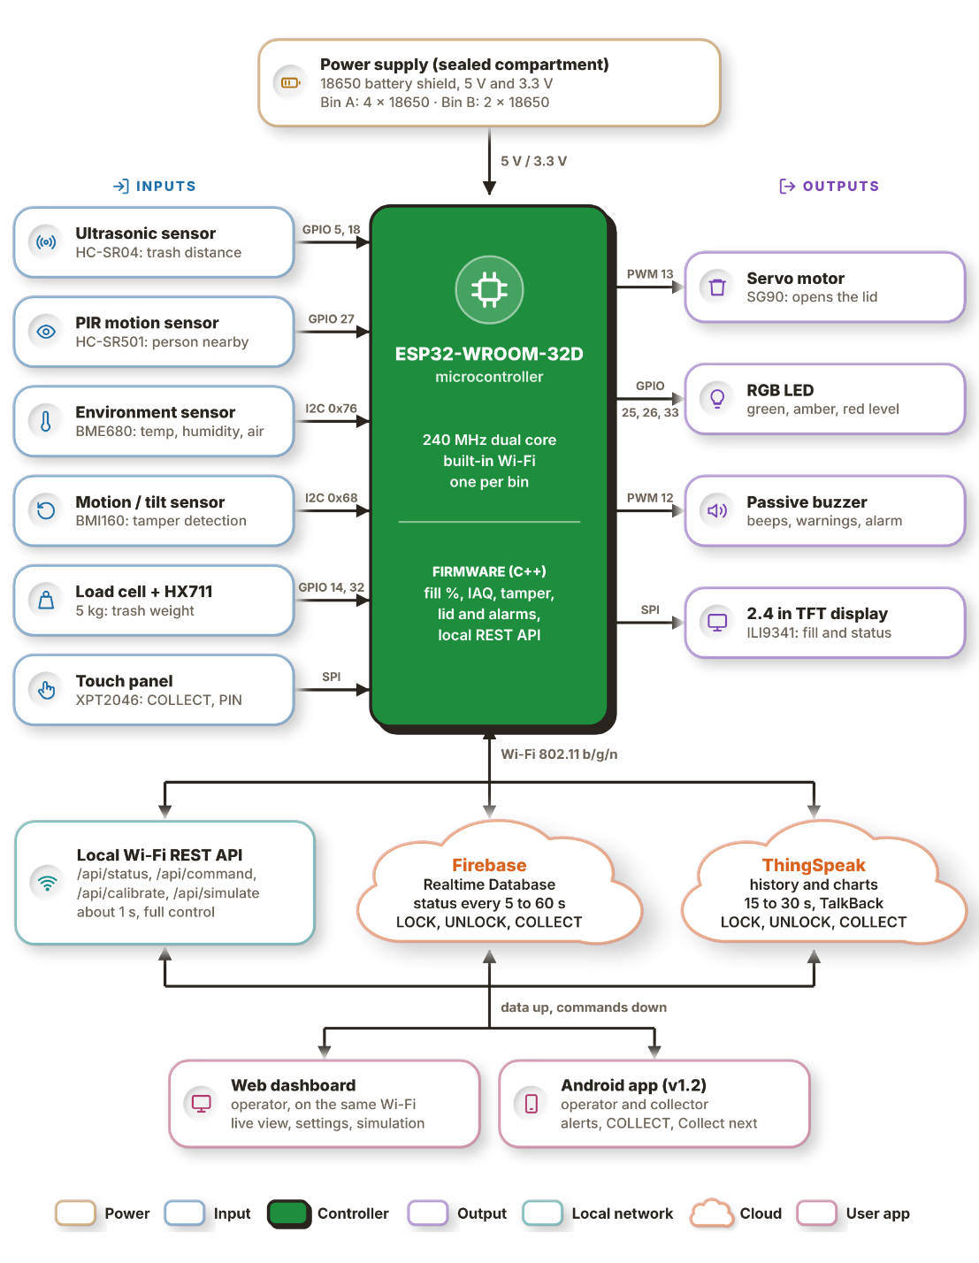
The power supply is in the upper part of the diagram, an 18650-battery shield in a sealed compartment. Provides the circuit with a 5V rail and a 3.3V rail. Bin A is powered by 4x 18650 cells, Bin B is powered by 2x 18650 cells. Both rails provide power to the ESP32-WROOM-32D, a 240MHz dual-core microcontroller which has integrated Wi-Fi. It has firmware programmed in C++ that calculates the fill percentage, indoor air quality (IAQ) reading and tamper state, controls the lid and alarms and supports a local REST API.
The inputs are on the left. The HC-SR04 ultrasonic sensor on GPIO 5 and 18 senses the distance between the lid and the trash and provides the fill level data, while the HC-SR501 PIR sensor on GPIO 27 senses a person approaching the trash bin. This I2C bus is shared by two sensors: the BME680 (address 0x76) provides temperature, humidity and air quality and the BMI160 (address 0x68) provides motion and tilt for tamper detection. The weight of the trash is measured using a 5kg load cell connected to GPIO 14 and 32 with an amplifier module HX711. On the SPI, the touch panel XPT2046 accepts the COLLECT and PIN inputs.
The outputs are to the right. The lid is opened and closed by the PWM pin 13 servo SG90. The fill level is indicated by an RGB LED (GPIO 25, 26 and 33) in green, amber or red, with beeps, warnings and tamper alarm via a passive buzzer (PWM pin 12). The 2.4 in. The fill level and the bin status is displayed on the ILI9341 TFT display (also SPI).
The lower half shows how data leaves the bin over Wi-Fi (802.11 b/g/n) through three paths. The local REST API (/api/status, /api/command, /api/calibrate and /api/simulate) answers in about 1s and gives full control of the bin. Firebase Realtime Database receives the status every 5 to 60s, and ThingSpeak stores the history and charts every 15 to 30s; both also carry the LOCK, UNLOCK and COLLECT commands, ThingSpeak through its TalkBack feature. Data goes up and commands come down to two user apps. The web dashboard runs in a browser on the same Wi-Fi and gives the operator a live view, settings and simulation, while the Android app gives operators and collectors alerts, the COLLECT command and the Collection Priority list.

2.3 System Flowchart
Figure 4
System Flowchart of the Smart-Bin
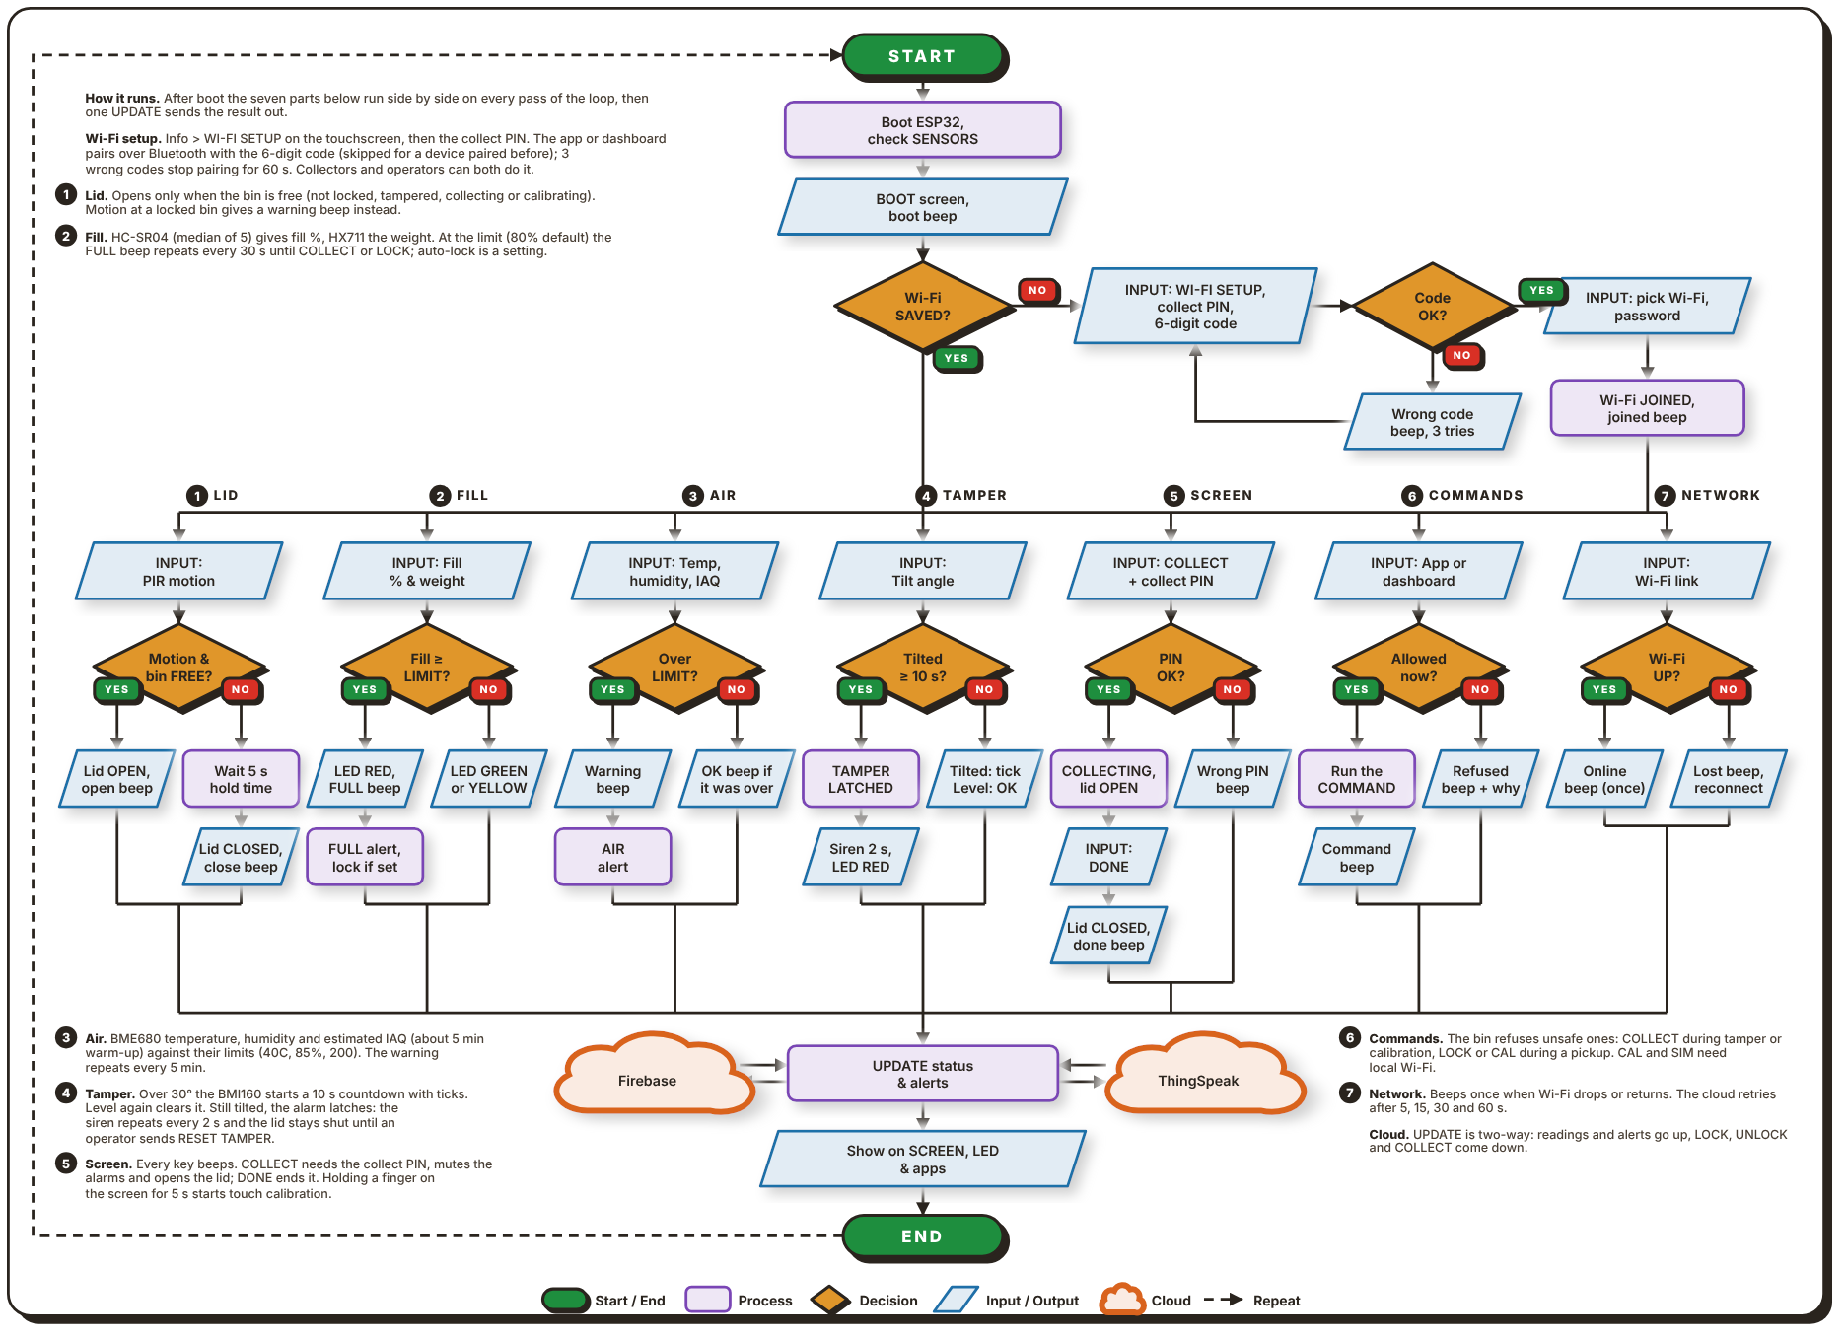
Note. Figure 4 shows the main program loop that runs on each bin. After start-up, seven parts run side by side on every pass of the loop, and their results meet at one update step.

Upon powering on the bin, the ESP32 starts, checks its sensors and loads its saved settings, with a boot screen and a beep. It then examines if a Wi-Fi network is saved. If not, the user opens WI-FI SETUP on the touchscreen and enters the collect PIN, and the app or dashboard pairs with the bin over Bluetooth. The 6-digit code on the bin's screen is typed into the pairing box (a device paired before skips it, and three wrong codes stop pairing for 60s). The bin sends back the Wi-Fi networks it can see, the user picks one and enters its password, and the bin joins with a beep. From here the loop branches into 7 parallel parts numbered 1 to 7 in the chart.
The lid part (1) reads the PIR sensor. If the bin is free (not locked, tampered with, collecting or being calibrated), it opens the lid with a beep. Otherwise the lid stays shut, and motion at a locked bin gives a warning beep. Five seconds after the movement stops, the lid closes with its own beep. The fill part (2) takes the median of 5 HC-SR04 readings for the fill percentage and reads the weight from the HX711. When the fill reaches the limit (80% by default), the LED turns red, an alert is sent and the FULL beep repeats every 30s until the bin is collected or locked. If auto-lock is on, the bin locks itself as well. Below the limit the LED is green or yellow. The air part (3) checks the BME680 temperature, humidity and estimated air quality against their limits (40C, 85% and an index of 200). The air quality is an estimate from the gas reading and needs about 5 minutes to warm up. Over a limit, the buzzer sounds and an alert is sent, repeating every 5 minutes, and a short beep tells when the reading is back under.
The tamper part (4) watches the BMI160 tilt angle. A tilt beyond 30° starts a 10s countdown with a tick each second. If the bin is steady again, the alarm clears by itself. If it stays tilted, the alarm latches: the siren repeats every 2s, the LED turns red, the lid stays shut and an alert is sent, until an operator sends RESET TAMPER. The screen part (5) handles COLLECT on the touchscreen. After the collect PIN is entered, the lid opens and the alarms are silenced until DONE is pressed, whereafter the lid closes and the fill level resets; a wrong PIN gives an error beep. Holding a finger on the screen for 5s starts touch calibration. The commands part (6) takes LOCK, UNLOCK, COLLECT, calibration (CAL) and simulation (SIM) from the app or dashboard. The bin refuses unsafe ones with a beep, such as COLLECT during a tamper alarm or a calibration, and both CAL and SIM are Wi-Fi only. The network part (7) beeps once when the Wi-Fi is lost and once when it returns.
All seven paths then converge at an UPDATE step. The two arrows between this step and each cloud indicate that the readings and alerts flow to Firebase and ThingSpeak, while the LOCK, UNLOCK and COLLECT commands flow back. The new status is then displayed on the screen, on the LED and in the apps, and the cycle repeats.
Figure 5
Operator Flowchart of the Smart-Bin Apps
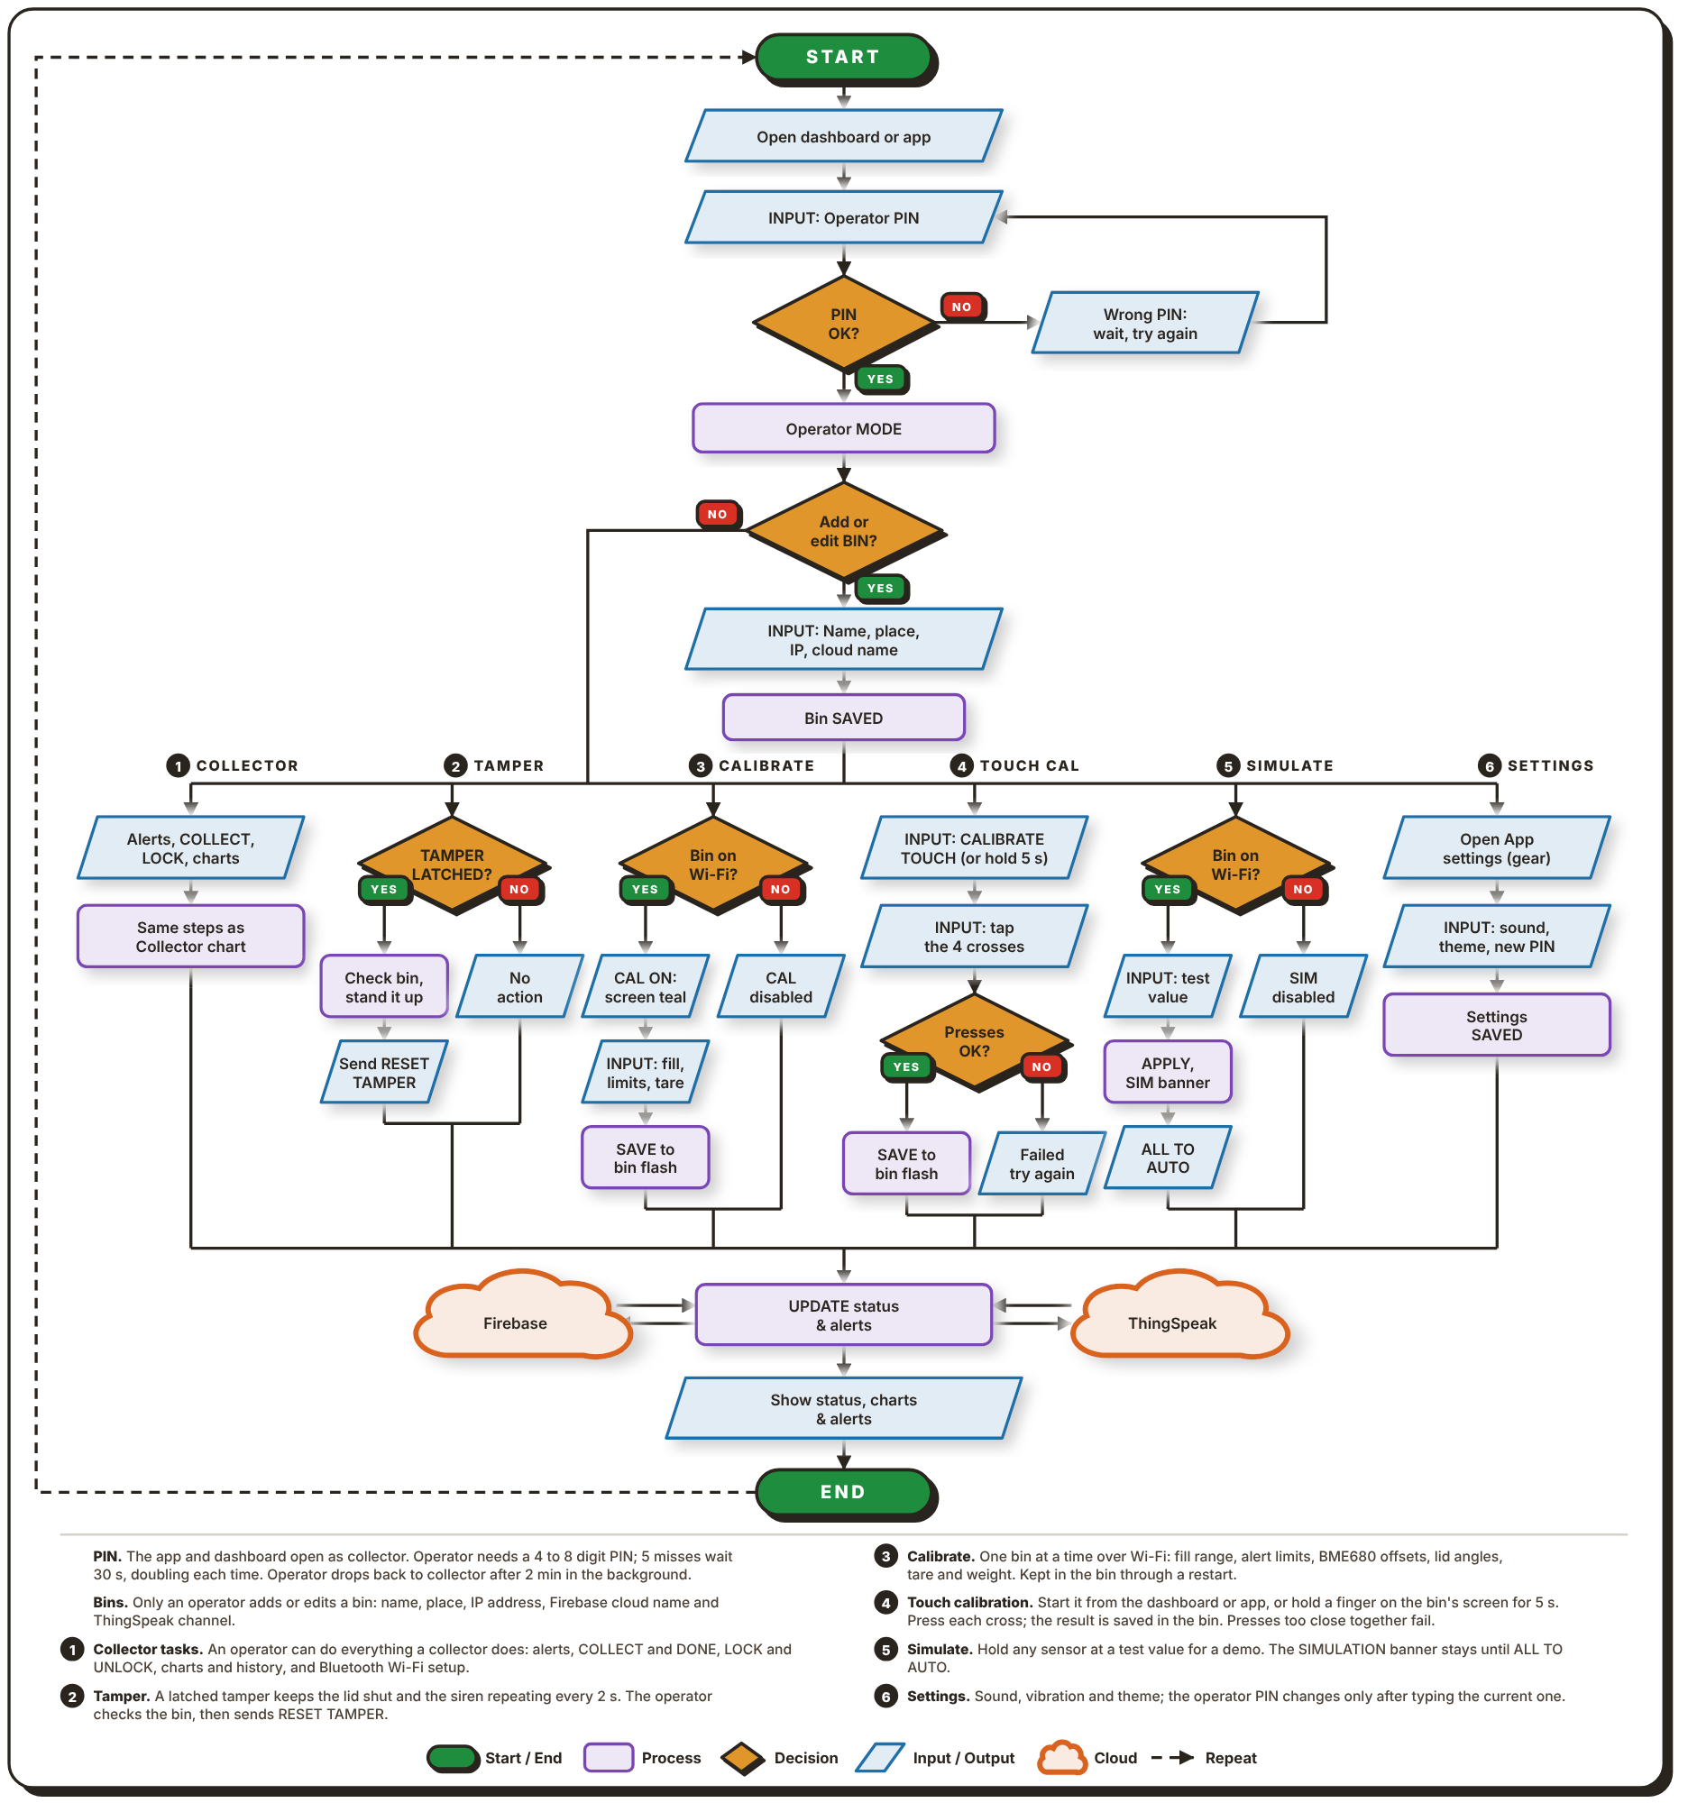
Note. Figure 5 shows what an operator does in the web dashboard or the Android app.
Both apps open in collector mode by default, so the operator first enters a PIN of 4 to 8 digits. A wrong PIN means waiting before the next try; five misses lock entry for 30s, and the wait doubles each time after that. With the right PIN the app switches to operator mode. The operator can then add or edit a bin by entering its name, place, IP address and cloud name for Firebase and ThingSpeak, and the bin is saved in the app.
Five tasks branch out from there. Collector (1) is everything a collector can do, as drawn in Figure 6: alerts, COLLECT and DONE, LOCK and UNLOCK, charts and history, and setting up the Wi-Fi over Bluetooth. Tamper (2) is for a bin whose alarm latched. Once the operator has checked the bin and stood it up, they send RESET TAMPER, which clears the alarm. Calibrate (3) needs the bin on the same Wi-Fi. The operator enters new limits, such as the fill range, alert limits, BME680 offsets, lid angles and weight tare, and these are saved in the bin's flash memory. If the bin is not on Wi-Fi, calibration is disabled. Touch calibration (4) starts from the dashboard or the app, or by holding a finger on the bin's screen for 5s. The operator presses four crosses in turn and the result is saved on the bin; presses that are too close together fail and the operator tries again.
Simulate (5) holds any sensor at a test value for demonstrations. While it is on, a SIMULATION banner stays on the screen until the operator sets everything back to AUTO. Settings (6) hold the sound, vibration and theme, and the operator can change the PIN there after typing the current one. Whichever task is used, the result goes through the same two-way UPDATE step with Firebase and ThingSpeak, and the app shows the new status, charts and alerts.
Figure 6
Collector Flowchart of the Smart-Bin Apps
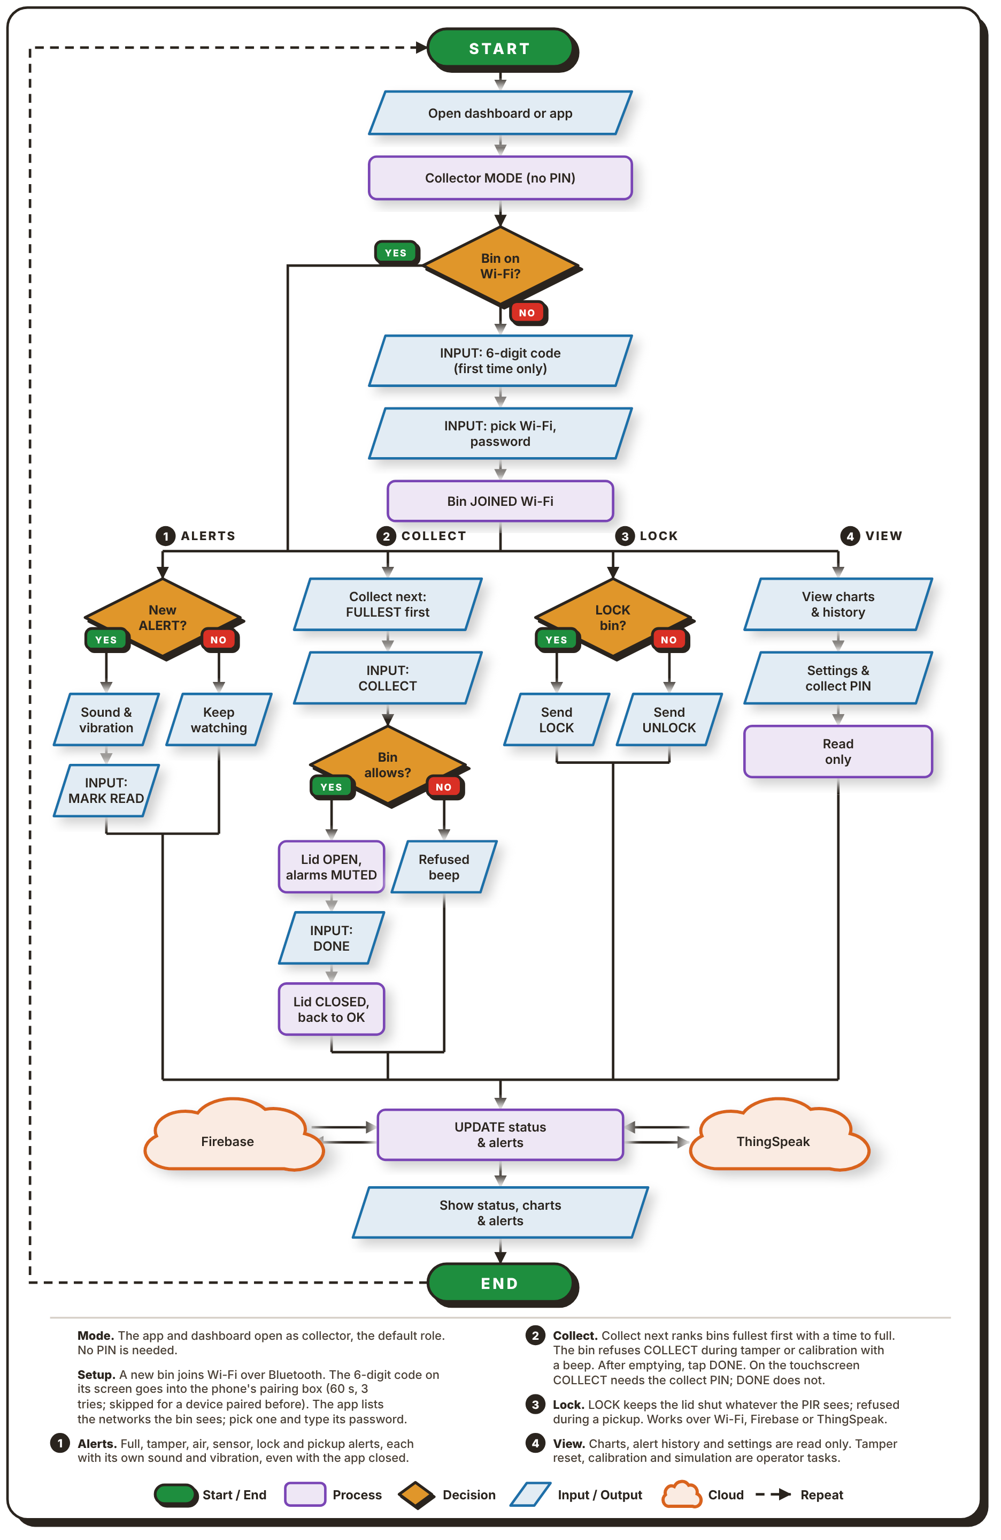
Note. Figure 6 shows what a collector does in the web dashboard or the Android app.

Collector mode is the default, so no PIN is required and the apps open to it. If the bin is not yet on Wi-Fi, the collector sets it up over Bluetooth. The 6-digit code on the bin's screen is typed into the phone's pairing box (it expires after 60s, three wrong tries stop pairing for 60s, and a device paired before skips the code). The app then lists the Wi-Fi networks the bin can see, and the collector picks one and enters its password. After the bin joins the network, there are four tasks available.
Alerts (1) are issued for a full bin, tampering, bad air, lock and pickup. Each has its own sound and vibration and they come even when the app is not in use. The primary task is collect (2). The Collection priority list is a ranking of the bins, with the first bin in the list being the one with the most capacity, and the time to fill each bin is shown. The collector taps COLLECT in the app or on the screen, and enters the collect PIN at the bin. Lid opens and alarms stop. The collector then empties the bin and taps DONE (no PIN required) and the lid will then close and the fill level will reset. A bin refuses COLLECT, with a beep, while a tamper alarm or a calibration is on.
Lock (3) allows the collector to lock or unlock a bin, while resetting a tamper alarm, calibration and simulation stay with the operator. View (4) displays the charts, alert history, and status and collect PIN in read-only mode. All tasks are completed with the same step in Firebase and ThingSpeak and the app updates the status.

2.4 Schematic Design
The circuit of each unit is drawn as one schematic split into three sheets: the microcontroller, the actuators and outputs, and the sensors and inputs. Figures 7 to 9 show the sheets in that order. Instead of long wires between sheets, each connection to the ESP32 carries a net label such as IO25, and pins with the same label are joined.
Figure 7
Schematic Diagram, Sheet 1: Microcontroller
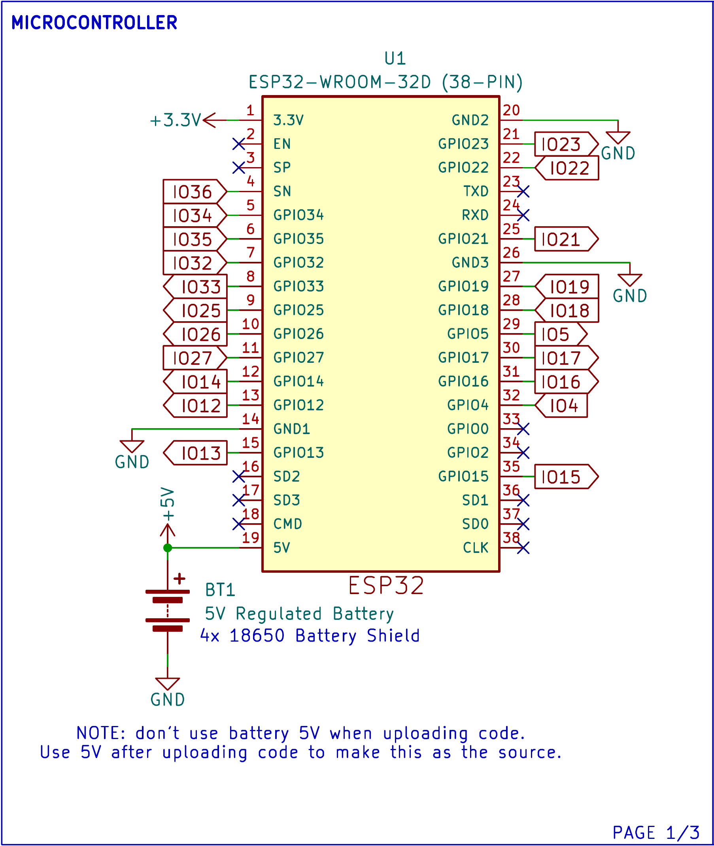
U1 is the ESP32-WROOM-32D on a 38-pin board. BT1, the 4x 18650-battery shield, supplies a regulated 5V to pin 19, and pin 1 gives the 3.3V rail used by the sensors. The ground pins share one GND net. Pins that the design does not use, such as EN, TXD, RXD, GPIO0 and GPIO2, are marked no-connect. A note on the sheet says the battery's 5V must not be used while code is being uploaded; it becomes the power source only after the upload.
Figure 8
Schematic Diagram, Sheet 2: Actuators and Outputs
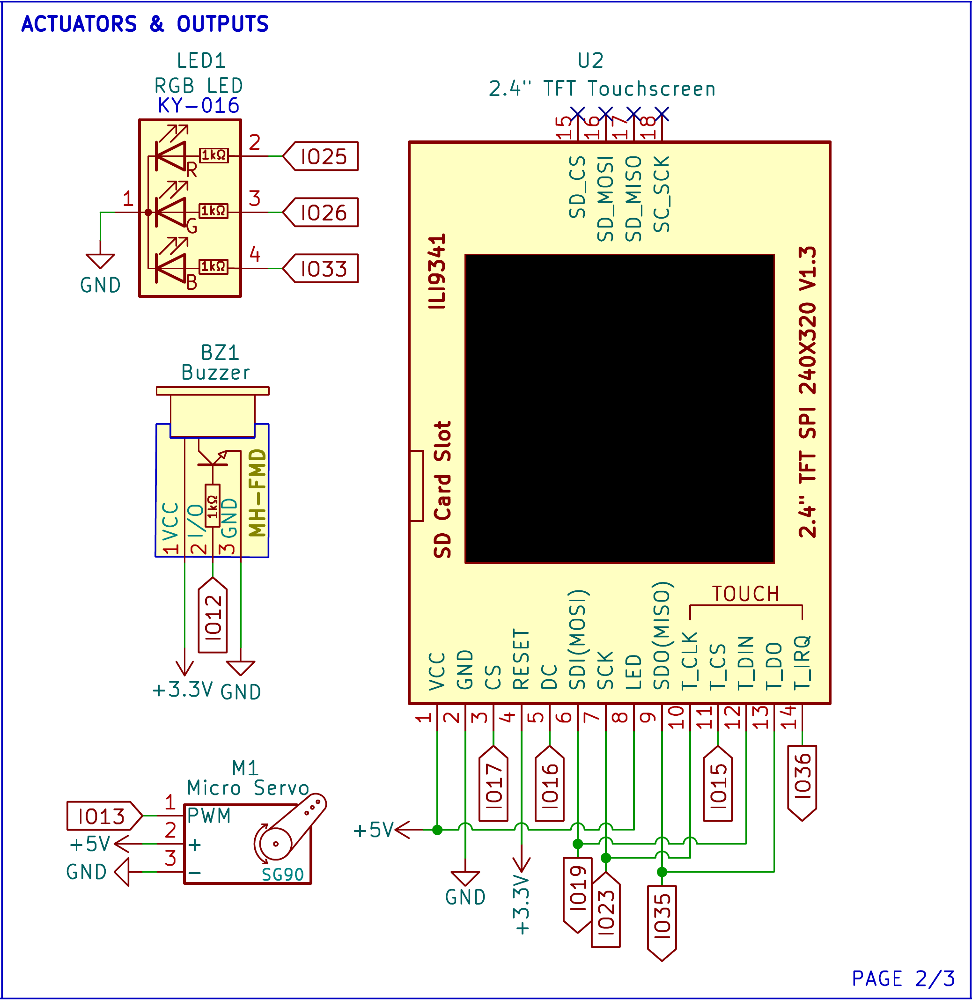
ED1 is a KY-016 common-cathode RGB LED. Its red, green and blue legs go through 1kΩ resistors to IO25, IO26 and IO33. BZ1, an MH-FMD buzzer module, runs on 3.3V and is driven from IO12. M1, the SG90 micro servo, takes 5V and its PWM signal from IO13.
U2 is the 2.4 in. ILI9341 touchscreen (240 × 320, SPI). The display and its touch controller share the SPI clock and data lines on IO19, IO23 and IO35, and each has its own chip select: IO17 for the display and IO15 for touch. DC goes to IO16, the touch interrupt T_IRQ to IO36, and RESET is tied to 3.3V. VCC and the backlight pin take 5V. The SD card pins are left unconnected.
Figure 9
Schematic Diagram, Sheet 3: Sensors and Inputs
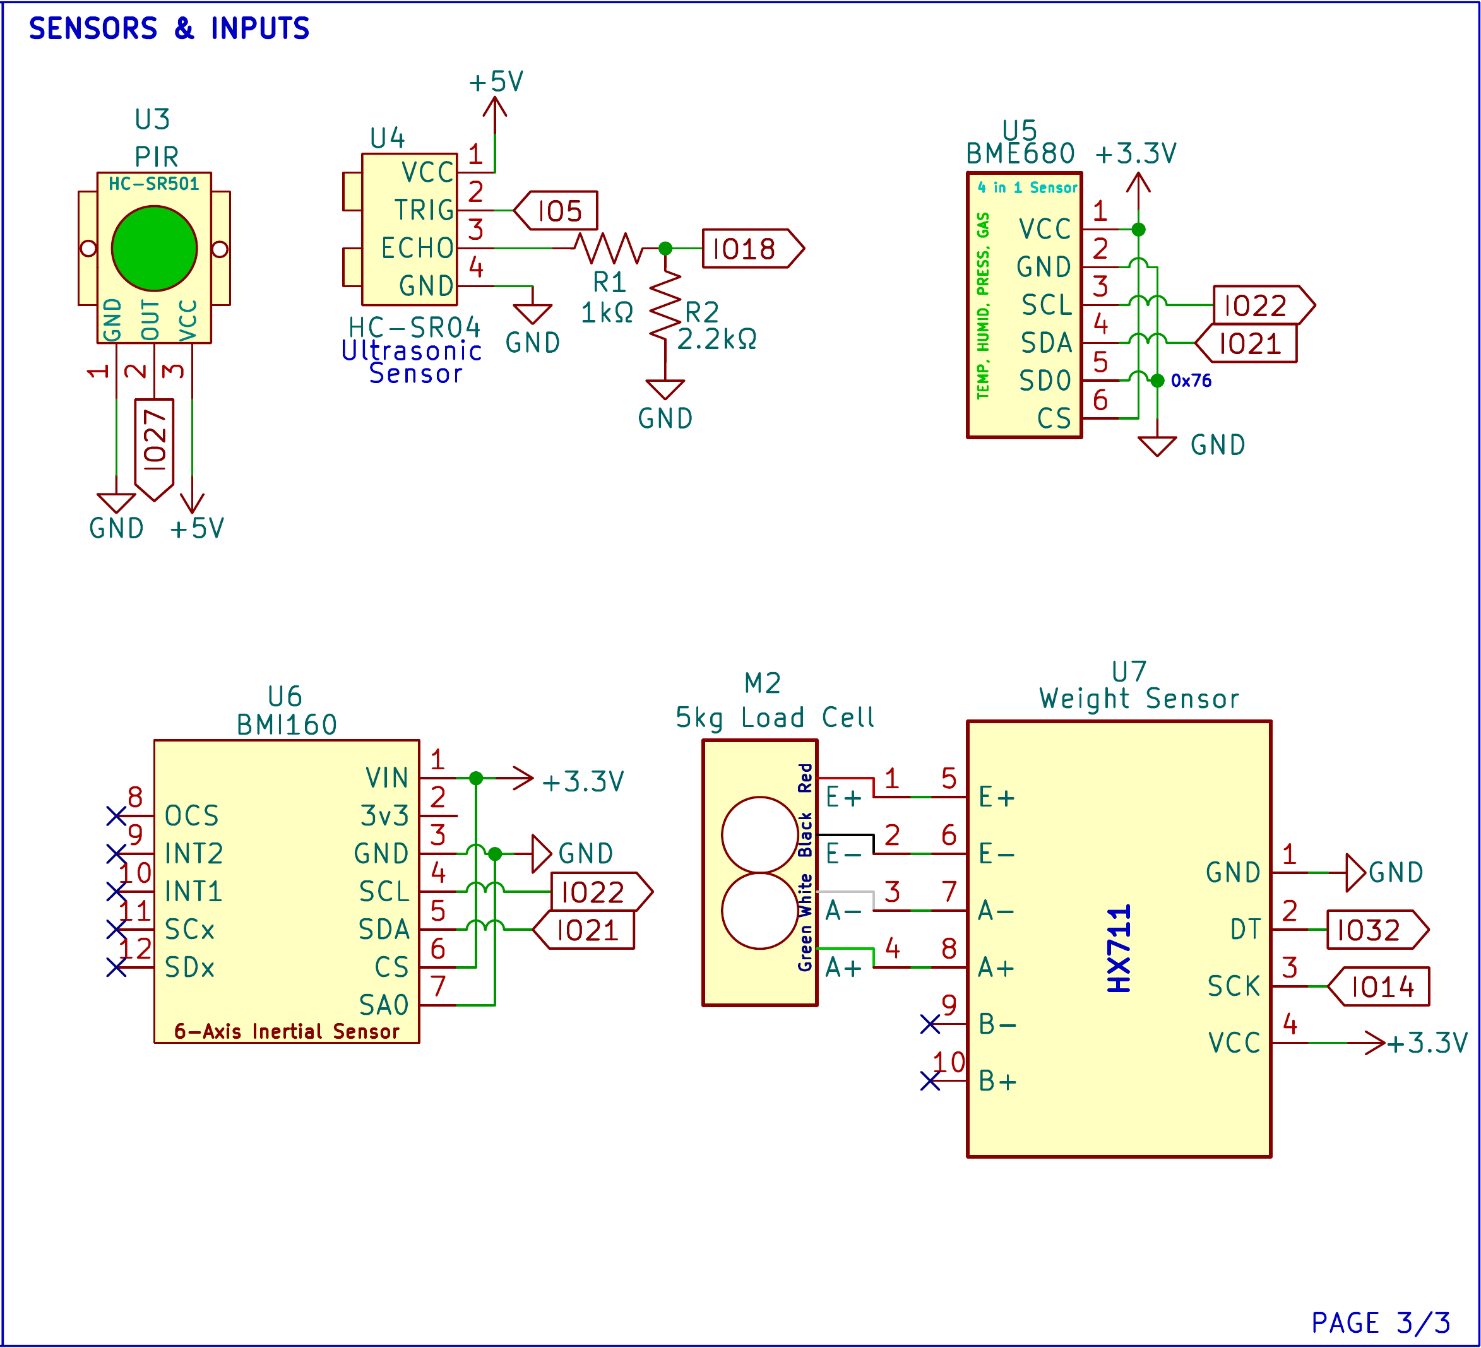
U3, the HC-SR501 PIR sensor, runs on 5V and sends its output to IO27. U4, the HC-SR04, also runs on 5V, with TRIG on IO5. Its ECHO pin returns a 5V pulse, so R1 (1kΩ) and R2 (2.2kΩ) divide it to about 3.4V before it reaches IO18, which keeps the ESP32 input within its 3.3V rating.
U5 (BME680) and U6 (BMI160) both run on 3.3V and share the I2C bus, with SCL on IO22 and SDA on IO21. Tying the BME680's SDO pin to ground sets its address to 0x76, and tying the BMI160's SA0 pin to ground sets its address to 0x68, so the two do not clash. M2, the 5kg load cell, connects its red, black, white and green wires to the E+, E−, A− and A+ inputs of U7, the HX711. The HX711 runs on 3.3V and sends its data on IO32 with its clock on IO14.

2.5 Component Materials
This section describes the main electronic parts used in each Smart-Bin unit. Both bins use the same parts except for the battery shield. Figures 10 to 20 show each part, followed by what it does and how the system uses it.
Figure 10
ESP32 DevKit V1 (38-Pin, ESP32-WROOM-32D)
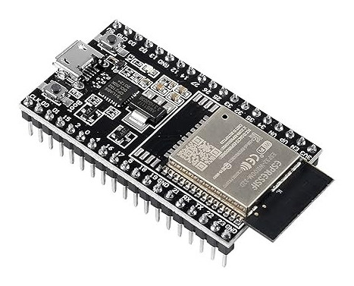
Note. Image from Sigmanortec (n.d.).
The ESP32 DevKit V1 is a development board built around the ESP32-WROOM-32D module. The module has a dual-core processor that runs at up to 240MHz, with Wi-Fi and Bluetooth on the same chip. The 38-pin board provides an additional USB connector for uploading code and power, a voltage regulator for 3.3V power and pin headers for breadboarding.
There is one board for each bin and each board governs all of the contents of that bin. It reads all six inputs, calculates the fill percentage, air quality reading and tamper state, and controls the servo, LED, buzzer and display. Providing the local REST API over Wi-Fi, it receives the status update command from the dashboard and the Android application and sends status update to Firebase and ThingSpeak.
Figure 11
HC-SR04 Ultrasonic Distance Sensor
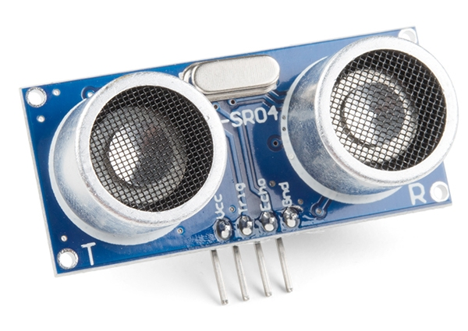
Note. Image from SparkFun Electronics (n.d.).
The HC-SR04 is a sound-based distance sensor. It outputs a 40kHz ultrasonic burst when a short pulse is received at its TRIG pin and will keep its ECHO pin high until the echo is received. The distance is determined by the width of that pulse which varies in the range of 2cm to 4m. The sensor runs on 5V.
In Smart-Bin it is installed under the lid and points downward, and thus measures the distance between the lid and the top of the trash. The firmware converts that distance into the fill percentage displayed on the LED, touch screen and the apps and once the fill level reaches 80% or more, the full-bin alert is activated. TRIG is wired to IO5, and ECHO is wired to IO18 with a 1kΩ and 2.2kΩ divider to keep the 5V pulse from being too large for the ESP32 to handle for its 3.3V input.
Figure 12
HC-SR501 PIR Motion Sensor
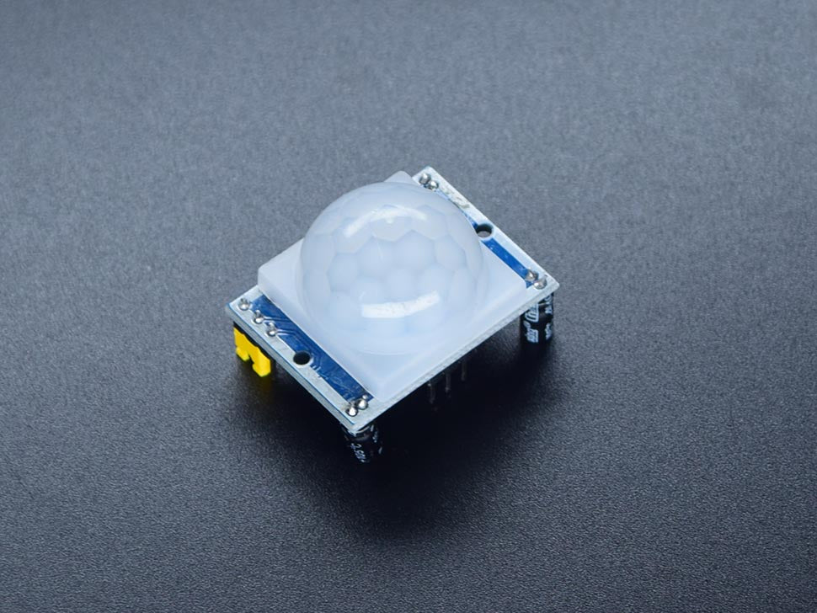
Note. Image from Circuitrocks (n.d.-c).
The HC-SR501 is a passive infrared (PIR) sensor. It detects the modulation of infrared light as a warm body passes in front of its white dome lens and its output pin will be "high" when motion is detected. The sensitivity and output high time is determined by two trimmers on the board.
It is used by Smart-Bin to determine when someone approaches the bin. When the output on IO27 is high and the bin is available for opening, the bin beeps and the servo raise the lid and the user never has to touch it. The lid will close 5 seconds (user definable length) after movement ceases. During COLLECT mode motion sensing is suppressed and the lid remains open while the collector is operating.
Figure 13
BME680 Environmental Sensor
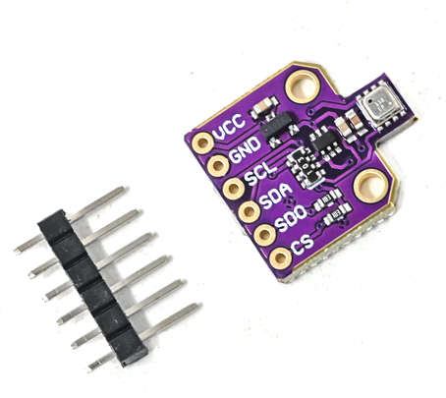
Note. Image from Robu.in (n.d.).
The BME680 is a single-chip sensor that detects temperature, humidity, air pressure and VOC (volatile organic gases). The gas reading can be converted to an indoor air quality (IAQ) index. It is powered by 3.3V and communicates via I2C.
In Smart-Bin it monitors the air within the bin. When a fire or hot material is detected, the firmware will generate an alarm, even if the bin isn't full yet, since a hot temperature may cause it to swell. It is located at I2C address 0x76 (SDO tied to ground).
The purpose of this is using the combination of temperature, humidity, and gas reading (IAQ) in order to determine by the collector or operator how much rotting trash is in the Smart-Bin for smell-sensitive areas.
Figure 14
BMI160 Six-Axis Inertial Measurement Unit
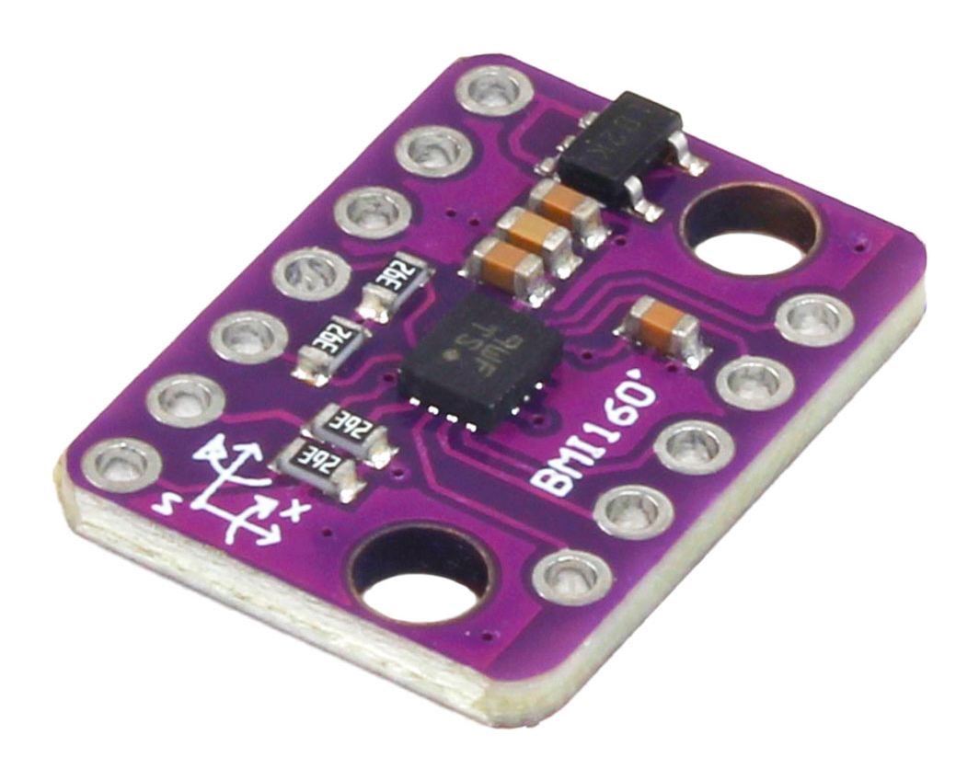
Note. Image from ElectroPeak (n.d.).
BMI160 is a 3-axis accelerometer and 3-axis gyroscopes integrated onto one chip. It is an I2C acceleration and rotation sensor that operates on 3.3V.
It is used by Smart-Bin for tamper detection. If the bin is tilted, shaken or knocked over, the readings jump past their limits and the firmware flags a tamper, sounds the buzzer alarm and keeps the lid shut. It shares the I2C bus with the BME680 at address 0x68, set by tying SA0 to ground. The tamper check is paused during COLLECT mode.
Figure 15
HX711 Load Cell Amplifier and 5kg Load Cell
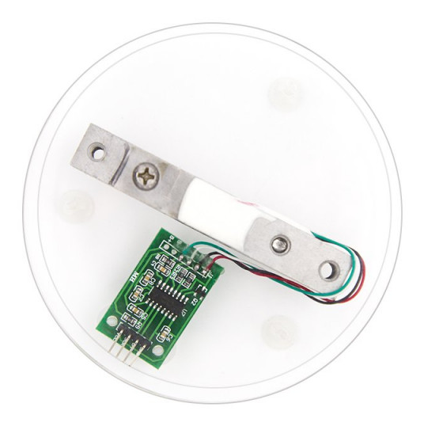
Note. The HX711 board and the 5kg load cell are shown on a display base. Image from ElectronicsComp.com (n.d.).
load cell is a metal bar with strain gauges designed so that as the load is applied, the bar's resistance varies slightly. The bar here is a 5kg model, and has a very small voltage output, which is amplified and converted in the HX711 board by a 24 bit analog to digital converter. The result is read by the ESP32 using two pins: DT (IO32) and SCK (IO14).
The two measure the garbage. Weight is a second check, wet waste will be heavy, but will not be tall, and a bin can be heavy but not tall. The weight is displayed on the dashboard and the app, and stored to the cloud with every measurement.
Figure 16
SG90 Micro Servo Motor
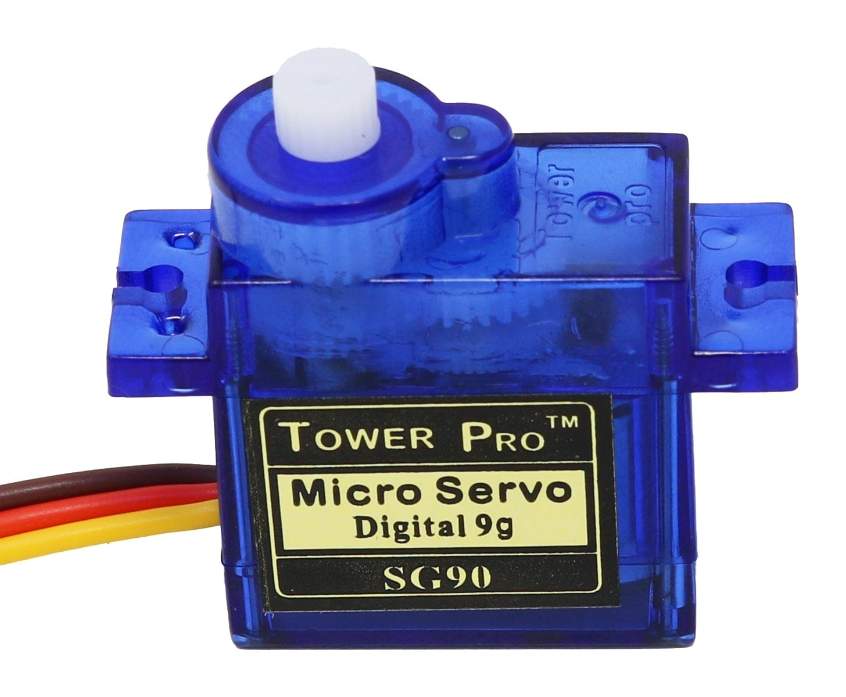
Note. Image from The Pi Hut (n.d.).
The SG90 is a small hobby servo which will rotate its output arm to a specific angle (roughly 180 degrees) depending on the width of a PWM pulse. Operates on approximately 5V and can be attached directly to the bin.
Servo is used to open and close the bin lid. It is controlled by ESP32, which opens the lid when a user is detected or when the collector taps COLLECT, and closes it 5s (user settable length) after it stops detecting motion, or when the collector taps DONE.. When the bin is locked, full or flagged for tampering, the firmware keeps the servo in the closed position.
Figure 17
2.4-in. TFT Touchscreen (ILI9341 With XPT2046 Touch Controller)
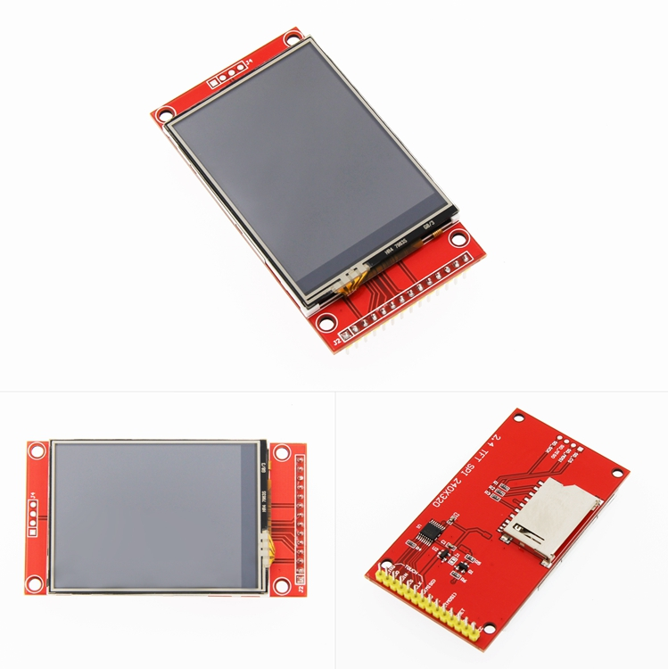
Note. Front, back, and angled views of the module. Image from LCDWIKI (n.d.).
This module is a 2.4 in., 240 × 320 color display driven by the ILI9341 controller over SPI. The same SPI bus also has a separate XPT2046 controller for the resistive touch layer on top. There is also an SD card slot on the board, which isn't used by Smart-Bin.
The bin's local screen is the display. It indicates the fill level, sensor readings and the bin status (LOCKED and TAMPER). The touch layer provides the collector with the buttons COLLECT, PIN and DONE, making it possible to empty a bin without the app.
Figure 18
KY-016 RGB LED Module
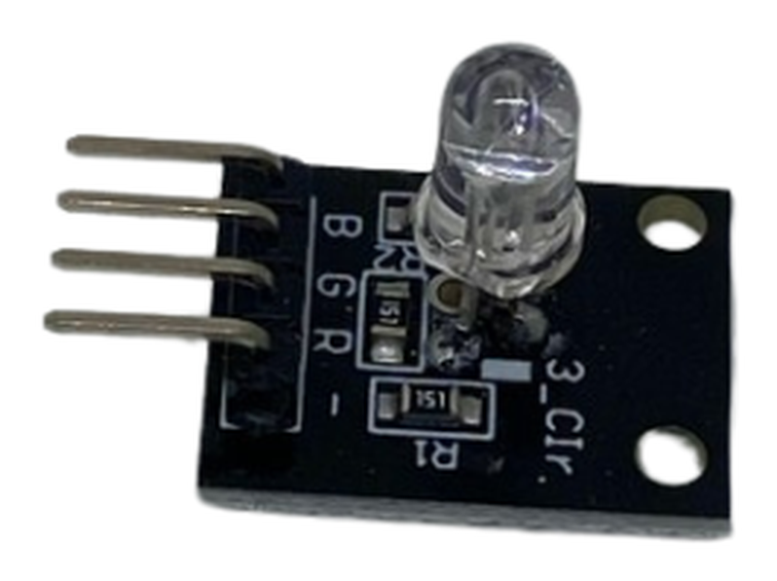
Note. Image from Circuitrocks (n.d.-d).
The KY-016 is a small board with a common-cathode RGB LED, a small package containing the red, green and blue chips. When the three colors are combined, other colors are created such as amber (red + green). A 1kΩ resistor is used for each colour to control the current.
The fill level is indicated on the LED, green if there is room in the bin, amber when it is filling up and red when the bin is full or a warning is triggered. It is powered from IO25, IO26 and IO33 and reverts to green when IO26 taps out the DONE signal.
Figure 19
Passive Buzzer Module (MH-FMD)
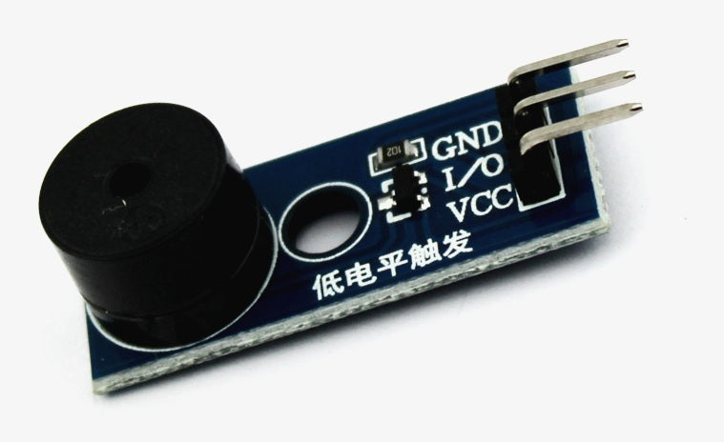
Note. Image from QuartzComponents (n.d.).
Passive buzzer: No built-in oscillator so it only buzzes if it is pulsed by the controller with a changing signal. This will allow the firmware to produce various tones and patterns, rather than just a single beep.
It is used by Smart-Bin for sound feedback from IO12. It alerts a user to the opening of the lid with beep, warns the user when the BMI160 detects poor air quality or when the air quality container is full, and alerts to tampering with the BMI160. It remains quiet while in COLLECT mode.
Figure 20
18650-Battery Shields for Bin A (4-Cell) and Bin B (2-Cell)
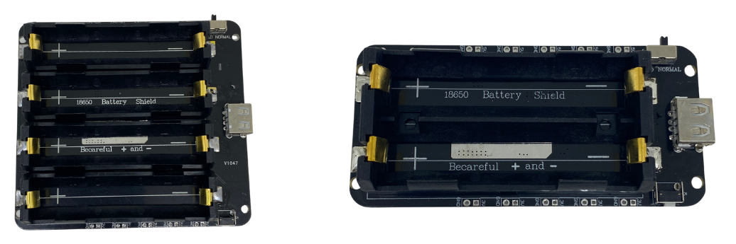
Note. Left: four-cell shield used in Bin A (Circuitrocks, n.d.-b). Right: two-cell shield used in Bin B (Circuitrocks, n.d.-a).
The 18650-battery shield comprises lithium-ion 18650 cells which will provide the electricity needed and convert its voltage to 5V and 3.3V regulated output. It also features a charging USB port for the cells. Bin A are equipped with a four-cell V9 shield (5V/3A), while Bin B are equipped with a two-cell shield.
The shield supplies power to the entire bin, without the need for a wall outlet, which allows a bin to be set anywhere that Wi-Fi is available. It is placed in a closed compartment and connected to the 5V of the ESP32 which provides 3.3V for the sensors. As mentioned in the schematic, the battery should not be connected during code upload via USB.

III. TESTING, RESULTS, AND CONCLUSION

3.1 Test Cases
[Introduce the test cases here. Each specific objective is tested below.]

Specific Objective 1: Sensor Monitoring and Detection
[Insert test cases TC1.1 to TC1.6 here.]

Specific Objective 2: Real-Time Monitoring and Alerts
[Insert test cases TC2.1 to TC2.6 here.]

Specific Objective 3: Bin Control and Collection Prioritization
[Insert test cases TC3.1 to TC3.6 here.]

3.2 Results and Discussion
[Present and discuss the test results here.]

3.3 Conclusion
[Write the conclusion here.]

3.4 Recommendations
[Write the recommendations here.]

REFERENCES
Circuitrocks. (n.d.-a). 2 channel 18650-battery holder protection board. Retrieved October 15, 2026, from https://circuit.rocks/products/2-channel-18650-battery-holder-protection-board
Circuitrocks. (n.d.-b). 4 channel 18650-battery holder protection board. Retrieved October 15, 2026, from https://circuit.rocks/products/4-channel-18650-battery-holder-protection-board
Circuitrocks. (n.d.-c). HC-SR501 PIR motion sensor module. Retrieved October 15, 2026, from https://circuit.rocks/products/pir-motion-sensor-module-digital
Circuitrocks. (n.d.-d). KY-016 RGB 3 color full-color LED module. Retrieved October 15, 2026, from https://circuit.rocks/products/ky-016-rgb-3-color-full-color-led-module
ElectronicsComp.com. (n.d.). 5 kg load cell with HX711 module shell and 4P DuPont wire kit. Retrieved October 15, 2026, from https://www.electronicscomp.com/5-kg-load-cell-with-hx711-module-shell-and-4p-dupont-wire-kit
ElectroPeak. (n.d.). GY-BMI160 module 6DOF 6 axis angular velocity. Retrieved October 15, 2026, from https://electropeak.com/gy-bmi160-module-6dof-6-axis-angular-velocity
LCDWIKI. (n.d.). 2.4inch SPI module ILI9341 SKU:MSP2402. Retrieved October 15, 2026, from https://www.lcdwiki.com/2.4inch_SPI_Module_ILI9341_SKU:MSP2402
Leones, J. R. (2025, March 3). Philippines ministerial statement [Paper presentation]. High-Level 12th Regional 3R and Circular Economy Forum in Asia and the Pacific, Jaipur, India. https://uncrd.un.org/sites/uncrd.un.org/files/12th3r_ps1-philippines.pdf
Philippine Statistics Authority. (2026). Highlights of the Compendium of Philippine Environment Statistics 2016–2025, Component 3: Residuals. https://psa.gov.ph/statistics/environment-statistics/highlights/component-3-residuals
QuartzComponents. (n.d.). Passive buzzer module with PCB. Retrieved October 15, 2026, from https://quartzcomponents.com/products/passive-buzzer-module
Robu.in. (n.d.). BME680 digital temperature humidity pressure sensor CJMCU-680 high altitude sensor module development board. Retrieved October 15, 2026, from https://robu.in/product/bme680-digital-temperature-humidity-pressure-sensor-cjmcu-680-high-altitude-sensor-module-development-board/
Sigmanortec. (n.d.). ESP32-DevKitC ESP32-WROOM-32D WiFi BT 38P development board. Retrieved October 15, 2026, from https://sigmanortec.ro/en/esp32-devkitc-development-board-esp32-wroom-32d-38p
SparkFun Electronics. (n.d.). Ultrasonic distance sensor - 5V (HC-SR04). Retrieved October 15, 2026, from https://www.sparkfun.com/ultrasonic-distance-sensor-hc-sr04.html
The Pi Hut. (n.d.). TowerPro servo motor - SG90 analog. Retrieved October 15, 2026, from https://thepihut.com/products/towerpro-servo-motor-sg90-analog
United Nations Department of Economic and Social Affairs. (n.d.). Goal 11: Make cities and human settlements inclusive, safe, resilient and sustainable. https://sdgs.un.org/goals/goal11
World Bank. (2022). An assessment of municipal solid waste plans, collection, recycling and disposal of Metro Manila (East Asia and Pacific Region: Marine Plastics Series). https://documents1.worldbank.org/curated/en/099125007222250938/pdf/P170994059e8e308c0a3ec02e0c4f57778b.pdf

APPENDICES

Appendix A: Gantt Chart
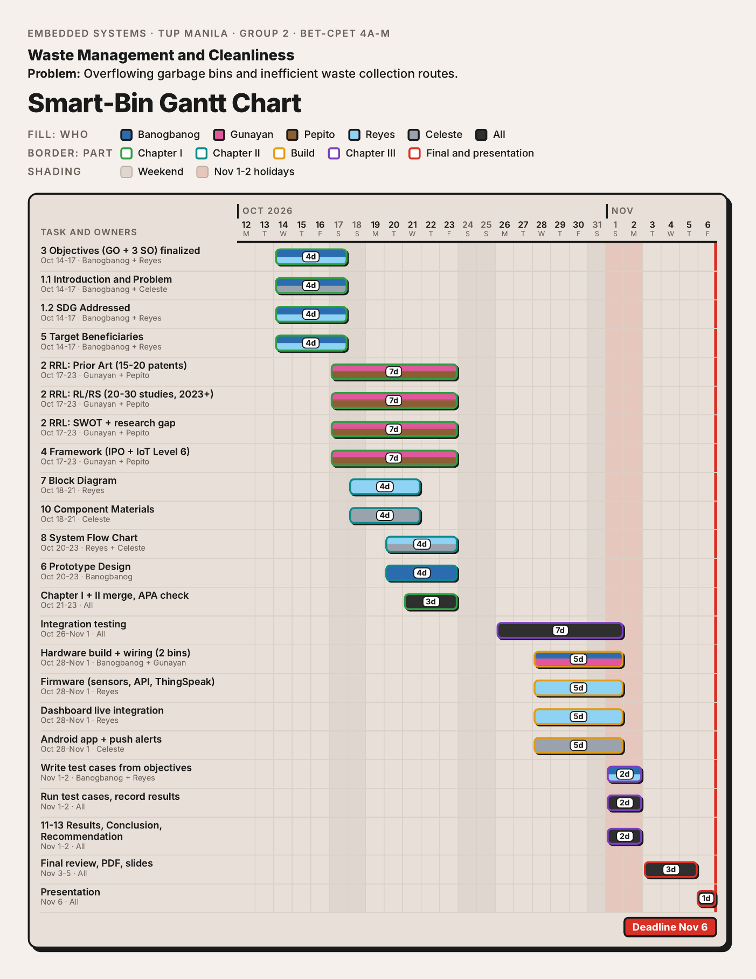

Appendix B: Bill of Materials
Table 1
Bill of Materials of the Smart-Bin Prototype
Component | Qty | Unit price | Amount
ESP32 DevKit V1 (38-pin, WROOM-32D) | 2 | ₱250.00 | ₱500.00
HC-SR04 ultrasonic sensor | 2 | ₱45.00 | ₱90.00
HC-SR501 PIR motion sensor | 2 | ₱55.00 | ₱110.00
SG90 micro servo motor (180°) | 2 | ₱65.00 | ₱130.00
2.4-in. TFT touch display (ILI9341 + XPT2046) | 2 | ₱280.00 | ₱560.00
BMI160 six-axis inertial sensor module | 2 | ₱80.00 | ₱160.00
BME680 environmental sensor | 2 | ₱400 | ₱800
HX711 load cell amplifier board | 2 | ₱60.00 | ₱120.00
5kg straight bar load cell | 2 | ₱120.00 | ₱240.00
RGB LED (common cathode, 5mm) | 2 | ₱8.00 | ₱16.00
Passive buzzer module (5V) | 2 | ₱12.00 | ₱24.00
Total (priced items) |  |  | ₱2,630.00
Note. For both bins, quantities are given. Components are counted at the market price of the group as of their check in September 2026.

Appendix C: User Interface Screens
[Insert screenshots of the touchscreen, web dashboard, and Android app here.]

Appendix D: Source Code
[Insert the firmware source code or a link to the repository here.]

